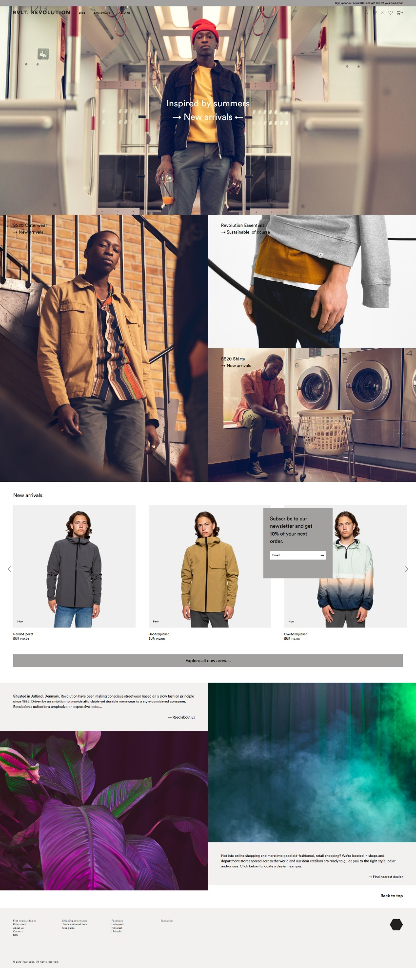

<https://www.rvlt.com/>

<https://www.rvlt.com/>

This website shows off pictures of its clothing by using a grid layout of different pictures of models in different settings which is a great way to do side by side comparisons.

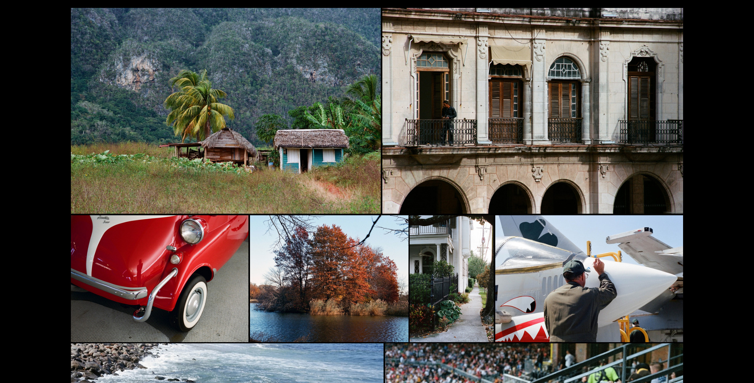

<https://marius.systems/photo>

This website uses black overlay mouseover effects and image transitioning animations which really makes the site come alive. Each photo you click on is actually a link to that specific photo gallery.

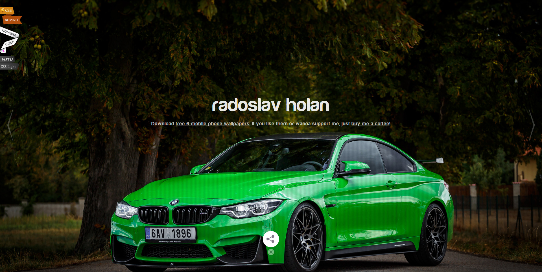

<https://www.radoslavholan.cz/>

This website uses a carousel to show off the artists work, this combined with the high quality of the images makes you want to click the next arrow over and over again.



<https://ic-creative.co.uk/>

The second you visit this site you are immediately greeted by a Gif animation of pencil shavings with a dark overlay. This site also has mouse over pop in effects for other photos.

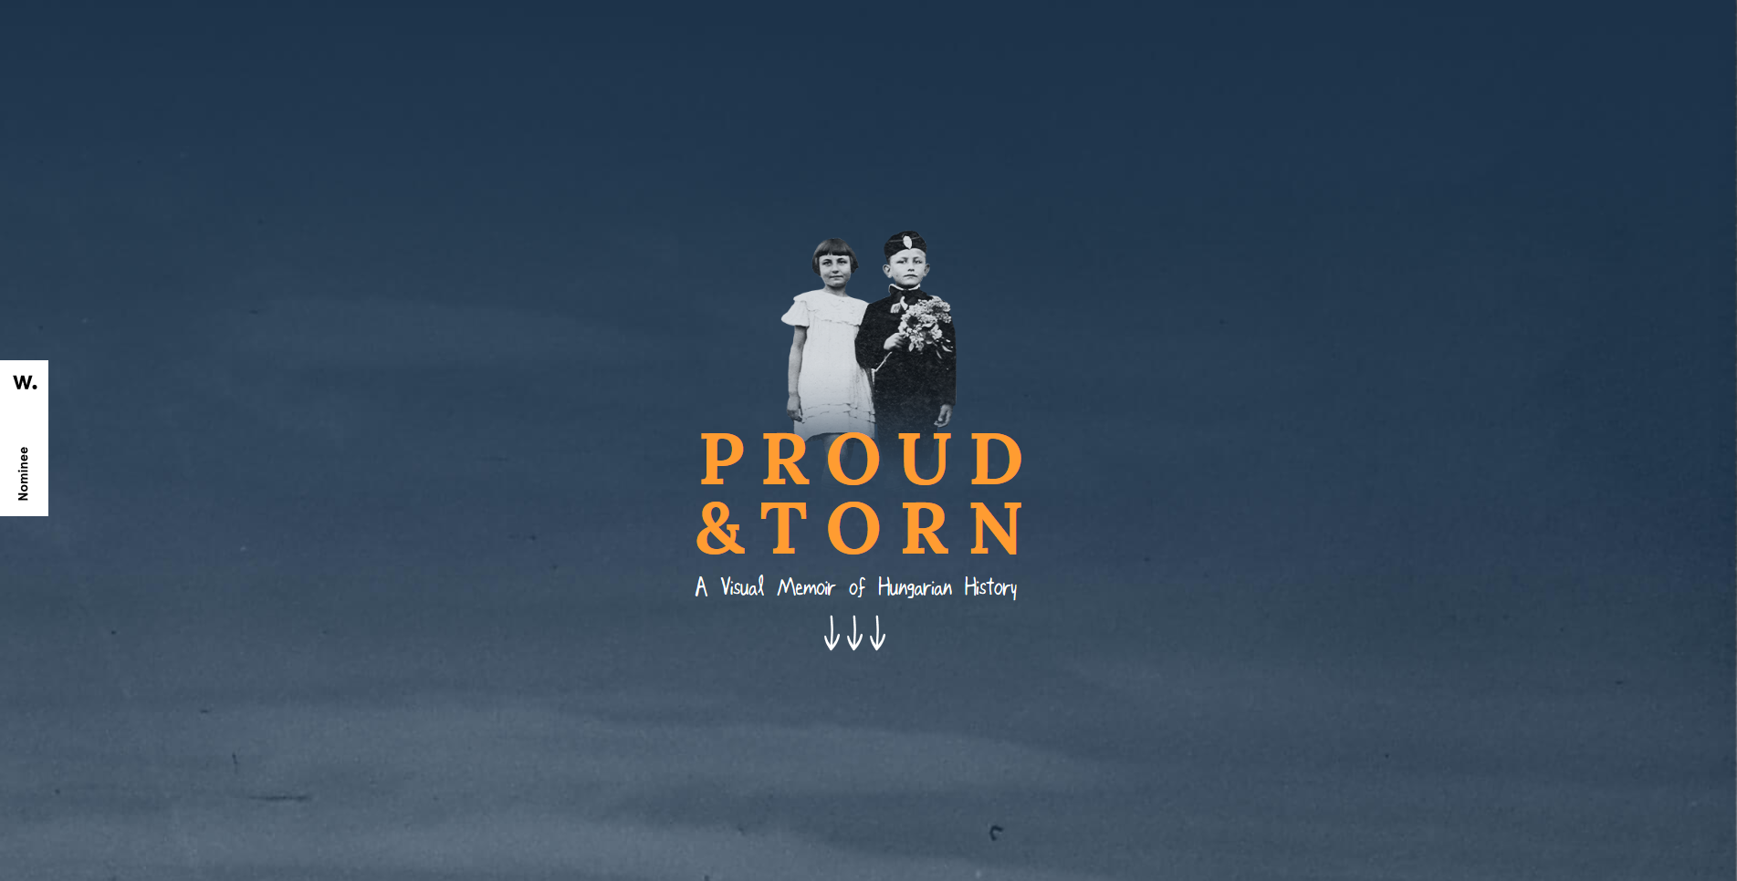

<https://proudandtorn.org/>

Proud & Torn uses a slightly muted color combination. The more subtle color palette helps create visual interest for a website that features a lot of colorless images. Descriptions really don’t do this site justice you really just need to see it to get a full understanding.

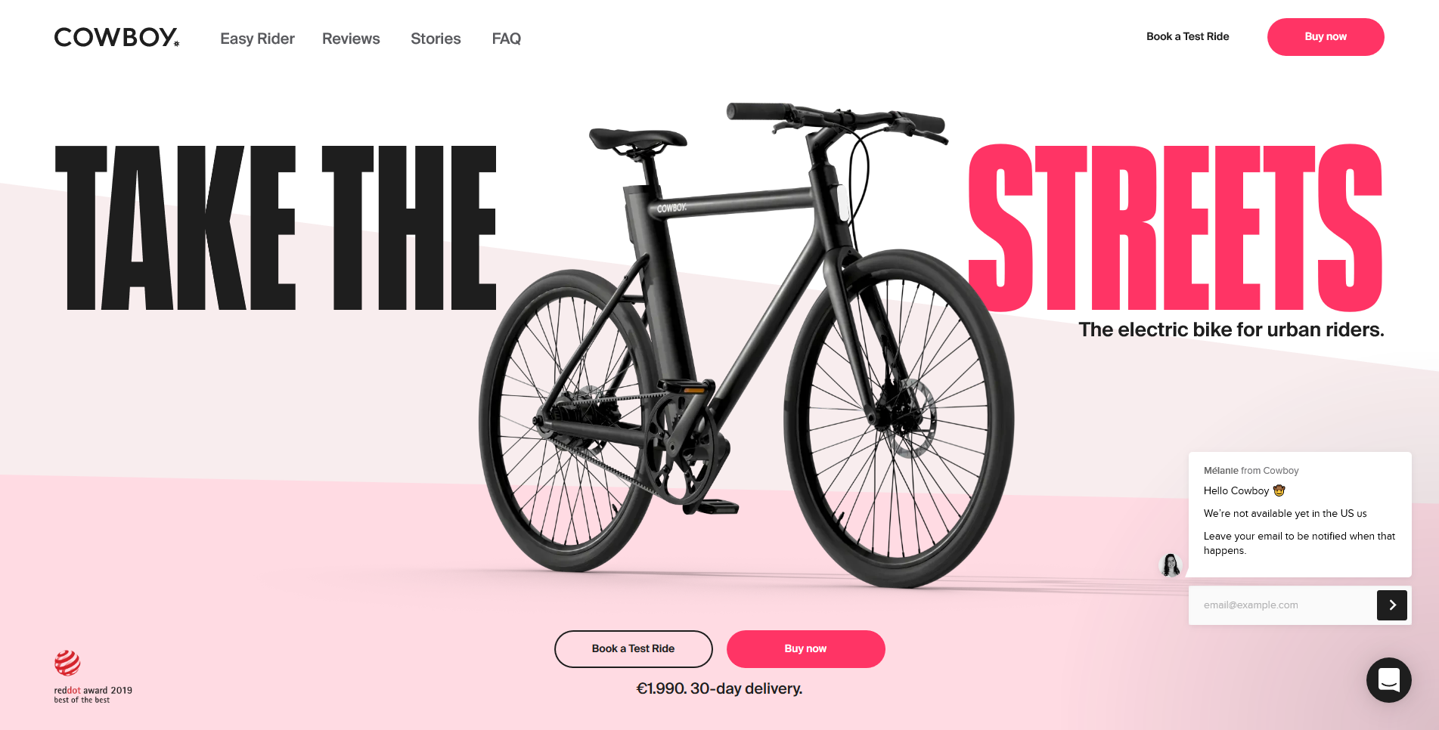

<https://cowboy.com/>

Cowboy Bike uses a black and bright color palette that’s an immediate attention getter. While most sites use black only for text, this design actually incorporates it into the bright, monotone palette. This with all the animations make for a terrific experience.